# Lab: AVL Tree Insertion

This document defines the **in-class exercises** assignments the ["Data Structures" course @ Software University](https://softuni.bg/opencourses/data-structures). Submit your code in the SoftUni Judge - <https://judge.softuni.bg/Contests/632/AVL-Trees-and-AA-Trees-Java-Lab>.

## AVL Tree Insertion

You are given a skeleton that supports the following operations:

* Node<T> Root 🡪 returns the root of the AVL tree
* bool Contains(T item) 🡪 checks if an element exists
* void EachInOrder(Action<T> action) 🡪 performs an action in order on each element
* void Insert(T item) 🡪 inserts an item into the tree

|  |
| --- |
| public class AVL<T> where T : IComparable<T>  {  private Node<T> root;  public Node<T> Root { get { return this.root; } }  public bool Contains(T item) { … }  public void Insert(T item) { … }  public void EachInOrder(Action<T> action) { … }  } |

And a node class:

|  |
| --- |
| public class Node<T> where T : IComparable<T>  {  public T Value;  public Node<T> Left;  public Node<T> Right;  public int Height;  public Node(T value)  {  this.Value = value;  this.Height = 1;  }  } |

Your task is to balance the tree after each insertion.

### Height

First, you should update the height of all nodes along an insertion path

You will need a method to find a node's height

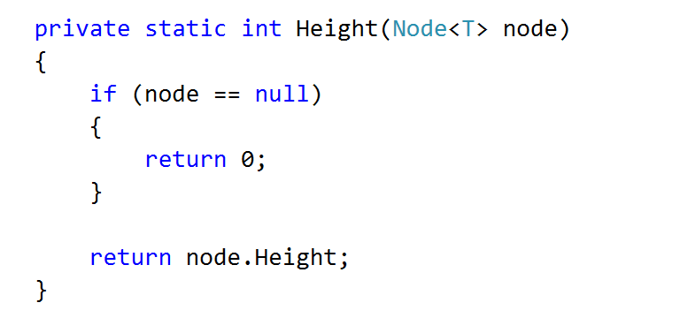

And a method to update a node's height

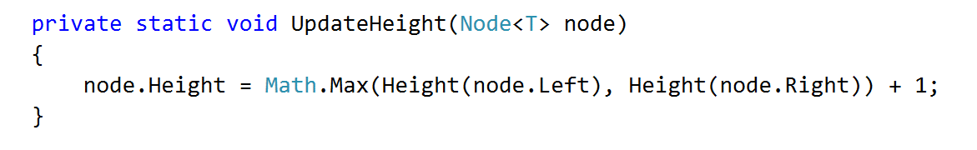

Consider when it is appropriate to update the height of a node



Check if Height tests pass

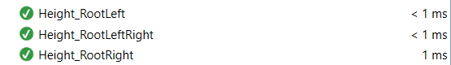

### Rotations

If you find it difficult to imagine the links that need to be updated in a rotation, refer to the presentation

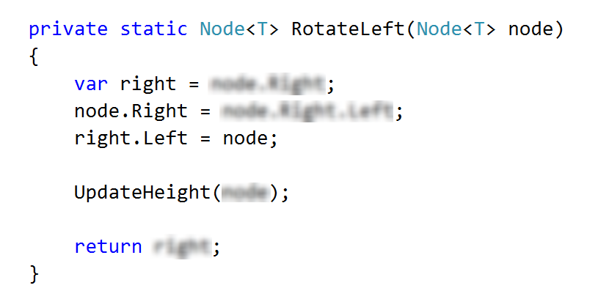

The right rotation is analogous.

### Balancing

Start by creating the method

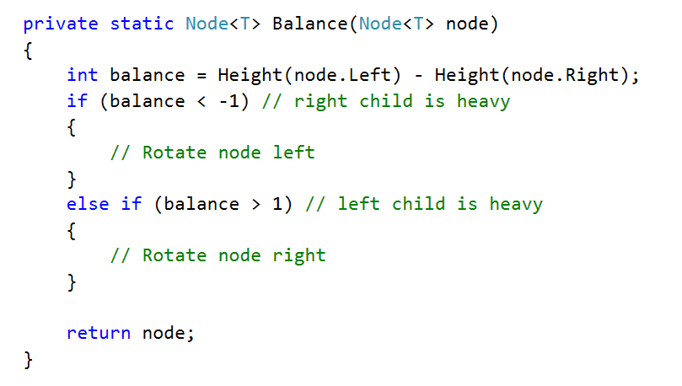

The first case (first if statement)

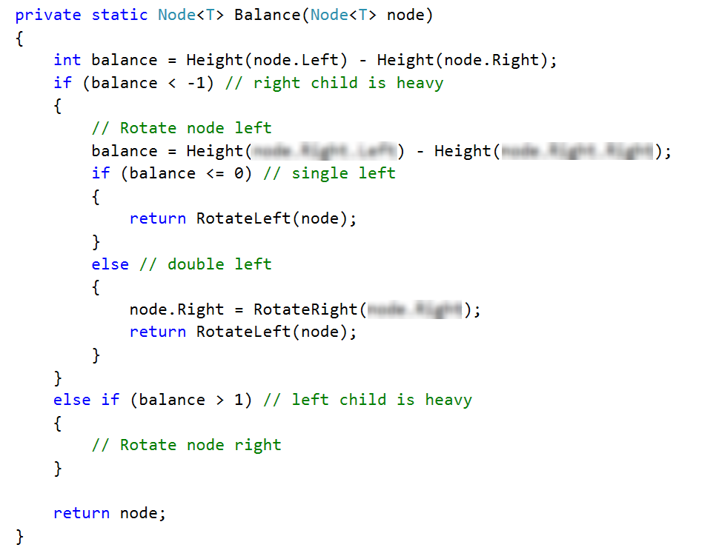

Right rotation is analogous to the left. Make sure that all tests pass:

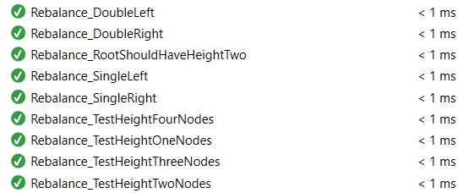

Congratulations, you have completed the lab for AVL Trees.